Section 8. Marketing Information –2Cs

Understand the potential consumers and competition is important for HackerNest’s success. HackerNest must gather information about the target market in South Korea before its foreign expansion. HackerNest should target to the millennials, which include high-school students, college students, and people who entered the work force in recent years. According to Nation Master, the millennial population constructs 13.6% of the nation’s population (*NationMaster.com*) (See Appendix G, Figure 1 for Age Distribution in South Korea). Since the population in Seoul is 10.29 million (*World Population Review*), HackerNest’s potential target market is consist of 1.4 million people. Traditionally, South Korean consumers were homogeneous in nature. However, now they appear to be embracing international influences. The living standard and food consumption patterns have seen rapid changes as a result of improvements to the economy, higher levels of education, international tourists, development of technology, increased personal incomes, and the adoption of western lifestyles. From 2007 to 2008, the overall annual consumption expenditures for households of two or more members increased in all categories except for the culture and entertainment category (See Appendix G, Figure 2 for Summary of Annual Consumption Expenditures for Households of Two or More Members, 2007-2008). The greatest expenditure increases were seen in education and fuel (8%), and light and water charges (6.3%). Expenditures for food overall increased by 5.3%, while expenditures for eating out increases 3.7% (*Foreign Law Guide*). South Korean consumers, especially the millennials, are well-educated and well-informed. The national literacy rate is 98%, and the country has the world’s best IT infrastructure, with exceptionally wide use of high-speed internet and smartphones “Spotlight on South Korea—Understanding the South Korean Consumer”. Because consumers are well informed or proficient in the use of modern technology, HackerNest would have a large target market. Korean consumers tend to be concerned with the brand name. Some Korean consumers typically research products online, especially through social media (*Foreign Law Guide*). Therefore, HackerNest should translate their official website into Korean, stay active on social media, and contact media and press to be featured online. Trends and celebrities have a large influence upon consumer preferences (Foxall 2005). HackerNest should reach out to video game celebrities and executives of technology firms to judge at hackathons because more than half of the population play online games regularly (Zhou, 2017). Although internet provides much of the information and country profile needed, HackerNest should send a group of employees to visit South Korea to feel how it’s like to live and work there to avoid ethnocentrism, which is a belief that the home country’s culture is the right way of doing things and the values of others aren’t important.

When entering South Korea, HackerNest should be aware of the competition exists in the South Korean market. Seoul Tech Society is a direct competitor as it is also an international non-profit organization that aims to build and unite tech community around the world (See Appendix G, Figure 3 for Seoul Tech Society Logo). Seoul Tech Society holds monthly tech meetups for people to collaborate on tech projects and host conferences for developers to share knowledge (*Seoul Tech Society*). Since Seoul Tech Society is based in Seoul, it might have a better reputation than HackerNest among the South Koreans. Therefore, HackerNest should utilize social media and press to gain public attention. Additionally, HackerNest has been sponsored by many large-scale and well-known organizations and IT companies, while Seoul Tech Society has not. Because South Korean consumers care about the brand name, HackerNest should list their sponsors on their advertisements. Another direct competitor is Global Hackathon Seoul. In 2015, this organization planned a four-day long hackathon that attracted 2000 hackers across the world. Global Hackathon Seoul had a considerable amount of support from its sponsors, as the airline tickers and hostel accommodation for all attendees would be fully sponsored. However, the hackathon canceled due to the outbreak of Middle East respiratory Syndrome in Asia. Sponsors pulled out, and the government of Seoul disagreed to host this event “Global Hackathon: Seoul Has Been Cancelled”. The cancellation of the hackathon gained Global Hackathon Seoul a dishonor (*Kompulsa*). HackerNest should learn from Global Hackathon Seoul’s lesson and prepare for a backup plan for every hackathon. Organizations and companies that help launch tech startups and host software and hardware developing courses are HackerNest’s indirect competitors. One example of HackerNest’s indirect competitor is Seoul Global Startup Center (See Appendix G, Figure 4 for Global Start-up Center Logo). Seoul Global Startup Center (SeoulGSC) is a startup incubation center that supports foreign entrepreneurs in Korea to begin their startup journey in Seoul. In the past year, SeoulGSC helped launch four foreign tech startups (*SeoulGSC*). SeoulGSC has a strong group of staff and mentors, and it is active on social media. However, SeoulGSC is only targeted to teams that have a ratio of at least 33% foreign residents of Korea in the co-founding team. In addition, teams have to apply to become a member of the SeoulGSC and the selection process is prestige (*Tech in Asia - Connecting Asia's Startup Ecosystem*). To compete against SeoulGSC, HackerNest should give everyone the opportunity to attend tech meetups and hackathons. When selecting hackathon participants, the judges should not only consider applicants’ background and expertise, but also their potential and interests.

In conclusion, consumer consideration and competition consideration are key factors that will influence the success of Hackathon’s foreign expansion.

Appendix G.

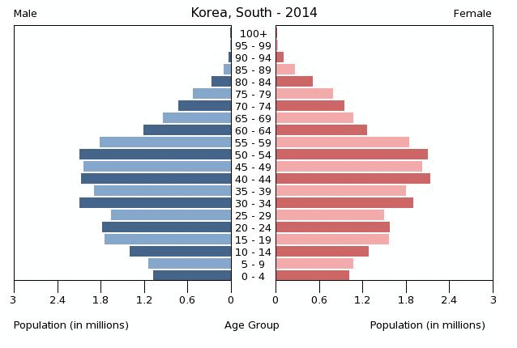

Figure 1.

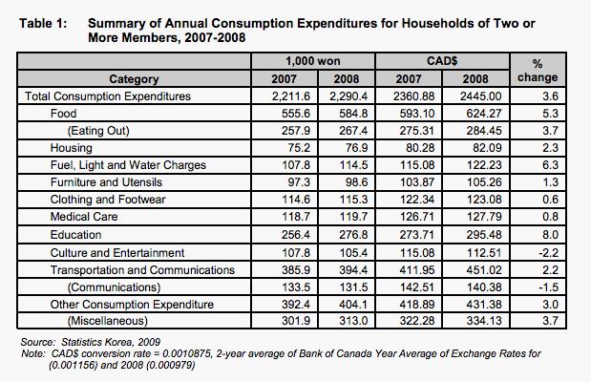

Figure 2.



Figure 3.

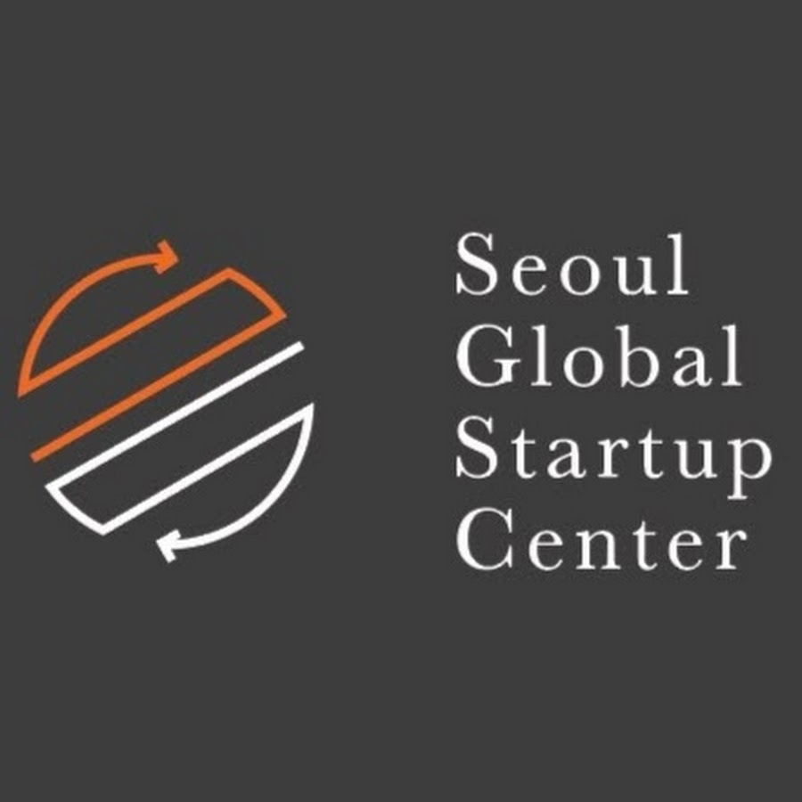

Figure 4.

<http://www.nationmaster.com/country-info/profiles/South-Korea/People/All-stats>

<http://worldpopulationreview.com/world-cities/seoul-population/>

<http://publications.gc.ca/collections/collection_2011/agr/A74-2-3-2011-eng.pdf>

<http://www.lek.com/sites/default/files/1113_SKoreaSpotlight_WEB_121613.pdf>

<https://www.thoughtco.com/south-korea-computer-gaming-culture-1434484>

<http://seoultechsociety.org/about>

<https://www.kompulsa.com/2015/06/18/global-hackathon-seoul-has-been-cancelled/>

<http://seoulgsc.com/qa/>

<http://seoulgsc.com/about-us/seoul-gsc/>

<https://www.techinasia.com/global-hackathon-seoul-connect-hackers>